Accessing your Meeting Reports

To access your meeting attendance report:
- Log in to WebEx online
- Click on your name in the upper right-hand corner and select “my reports.”
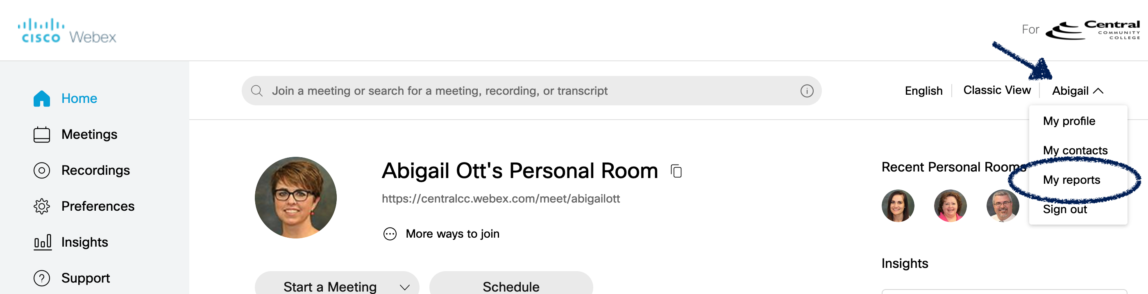

- Click on “Usage Report” under “All Services.” 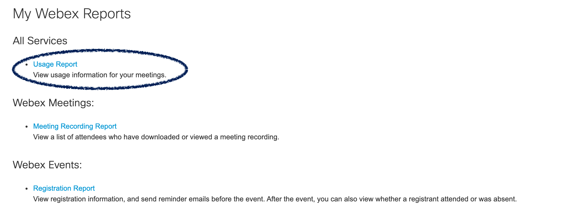
- Changing dates is not necessary, but you can limit the report to today’s date (Aug. 13) if you wish.
- Then, click “Display Report.”
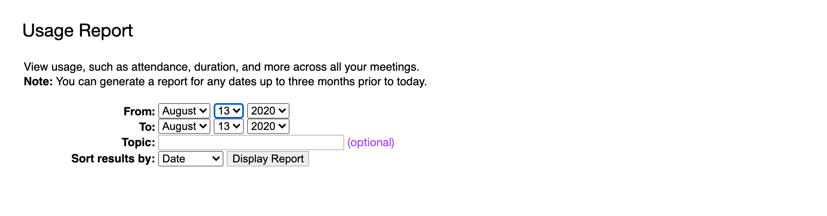
- Click on your class session
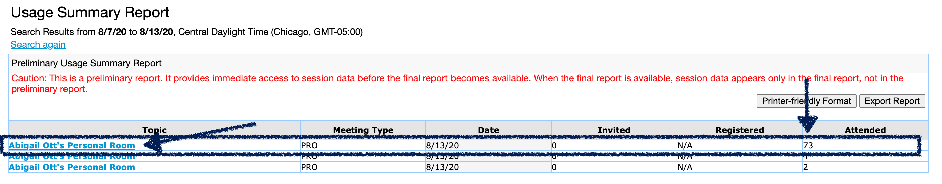
- A “Session Detail Report” will open and you can click the “Export Report” link to download the attendance report.
