WebEx for Instruction

Keep Teaching Website
- https://cccneb.instructure.com/courses/94

Student WebEx Tutorial
- https://app.vidgrid.com/view/k0fX91hA5Gdf/?sr=RqCirt

WebEx Help
- https://help.webex.com/en-us/
- https://help.webex.com/ld-nyw95a4-CiscoWebexMeetings/Webex-Meetings#Get-Started

CCC Service Center
- 308-398-7999

Cisco WebEx Test Meeting
- https://www.webex.com/test-meeting.html

Personal Rooms
- Configure your preferences
- Office Hours

Tools for Scheduling
- http://centralcc.webex.com

Downloads > Outlook Productivity Tools
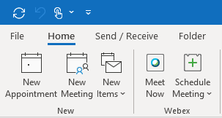

Joining a WebEx - App vs browser (We recommend using the Desktop App)
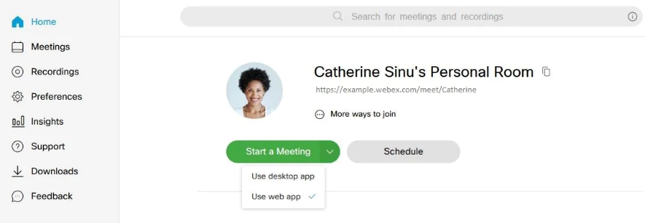

The following are the known limitations for choosing how you join your Webex Meetings from Modern View:
- Internet Explorer, Microsoft Edge, Google Chrome, Mozilla Firefox, Safari, or Chromium on Linux are supported by the web app. Other browsers are not compatible.
- The default setting for how you join your Webex Meetings from Modern View is set by your site administrator.
- The web app doesn't support meetings that use legacy VoIP.

Content Sharing
- https://help.webex.com/en-us/ntx2aid/Share-Motion-and-Video-Content-in-Cisco-Webex-Meetings
- https://help.webex.com/en-us/k0yf2g/Enable-Music-Mode-in-Webex-Meetings-and-Events

Coming Soon!

UI Updates
- https://www.cisco.com/c/dam/en/us/td/docs/collaboration/webex_centers/esp/wbxM_IG_in-meeting_WBS40-9_DSK.pdf

Breakouts & other Training Center features are coming to meetings … training to be retired
- https://help.webex.com/en-us/n8dklav/Explore-Training-Capabilities-in-Webex-Meetings
*Until then use personal rooms

End of Support for Windows 7 and Internet Explorer 10
In the upcoming 40.9 update, Cisco Webex will officially end support for the Windows 7 operating system and the Internet Explorer 10 browser.
Cisco will no longer provide bug fixes or updates for this operating system and browser. While users on these platforms will not be prevented from joining or starting meetings for now, we can no longer guarantee a fully functional operation. To have the best meeting experience possible, plan to upgrade your operating system and browser.
Please note that we are actively working on establishing dates to prevent the users on these platforms from joining Webex meetings in the future. We will provide advanced notice once we have the dates.

